Create MSSQL RDS Instance and import football league data.

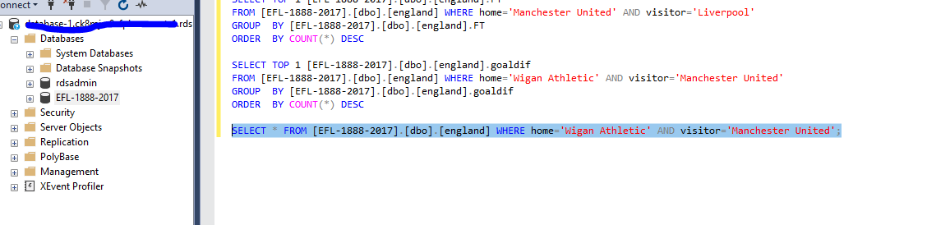

Create Lambda Function

allow lambda to access vpc

<https://docs.aws.amazon.com/lambda/latest/dg/configuration-vpc.html>

“You can configure Lambda to access your RDS instance.

You can enable this using Lambda management console. Select Lambda function which need access to RDS instance and then go to Configuration -> Advanced settings and select the VPC (which is your RDS instance is in) you need it to access.”

Function moved into Lambda in node js

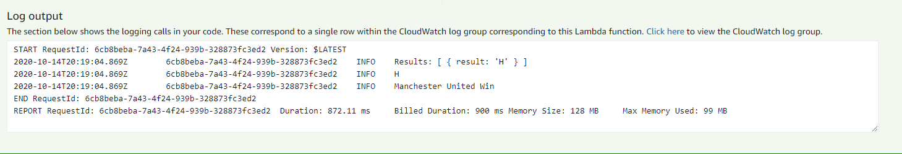

API Gateway configured

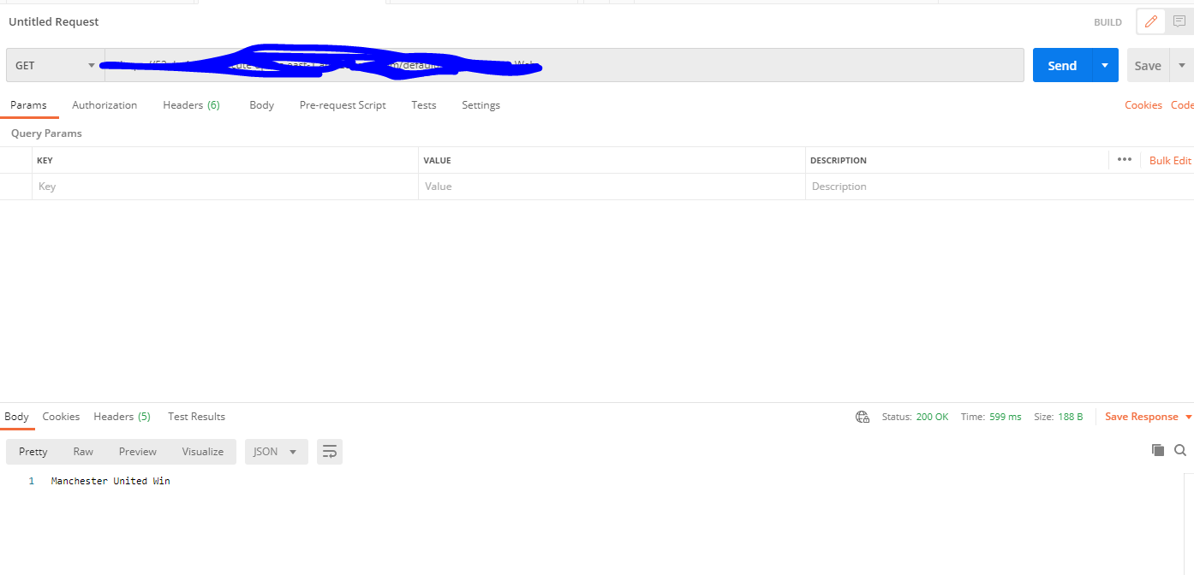

Next Steps

* Home and away team parameter added to api gateway to invoke lambda
* S3 front end take home team and away team values hit api end point return result
* Add validation to protect from SQL Injection
* Phase 1 complete
* Phase 2 – additional queries